**HOW NOT TO FETCH DATA IN REACT**

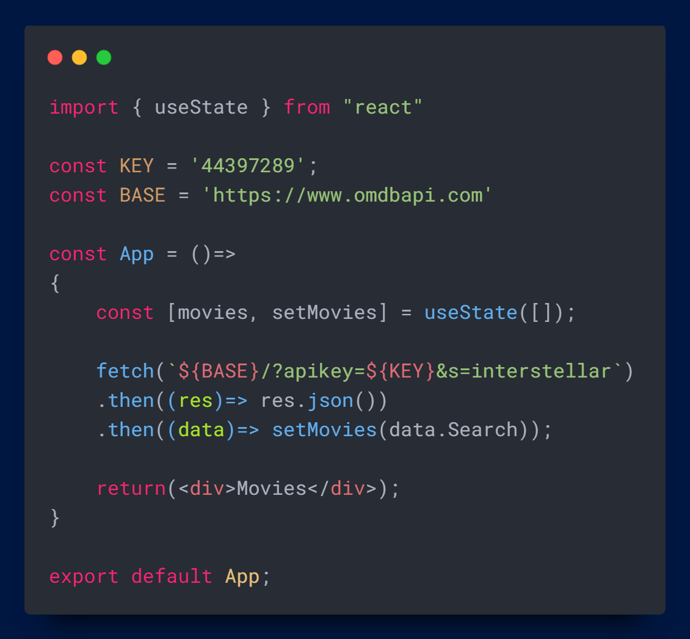

When we check Network Tab, we will find infinite many requests and it will keep running infinite number of requests because we are setting the state in render logic and it will immediately cause the component to render itself again.

As the component re-renders, the function will be executed again which then fetch again and set the state again as well.

This whole thing starts over and over again which is an infinite loop. That’s why setting state is not allowed in render logic.

**Do you find it helpful?**

**Let me know down in the comments.**



[](https://www.linkedin.com/in/anubhav-gupta-b68946132/)

**Click To Follow For More On LinkedIN**